AI IDEA FORGE
AI Product Discovery Platform
University Capstone Project — Week 2: Core Build Documentation
High-Level UI/UX Design Concepts
Project Name: | AI Idea Forge
Document Title: | AI Product Discovery Platform – High-Level UI/UX Design Concepts
Prepared By: | Batch 4 – Group 8
Date: | August 1, 2026
Prepared from a UI/UX design perspective, focusing on interface strategy, visual language, and user experience reasoning.

1. Introduction

Purpose of the Platform
AI Idea Forge is an AI-assisted product discovery platform designed to help early-stage founders and innovators move from a raw idea to a validated, structured business concept. Rather than requiring users to manually research markets, competitors, and feasibility, the interface is built around a guided discovery journey where an idea is progressively analyzed, scored, and translated into actionable insight. From a design standpoint, the objective was to make a traditionally research-heavy, time-consuming process feel approachable, visual, and immediate.

Target Users
The platform is designed for a specific but broad audience: early-stage startup founders, student entrepreneurs, product managers exploring new concepts, and innovation teams inside larger organizations. These users typically share three characteristics that shaped the design — they are time-constrained, they are not necessarily trained researchers or analysts, and they need to communicate their findings to others (investors, mentors, teammates) in a credible, presentable format. The interface was designed to serve all three needs simultaneously.

Why the Interface Was Designed Around AI-Assisted Discovery
Because the core value of the product is intelligence rather than data entry, the interface intentionally minimizes manual input screens and instead foregrounds the analysis process itself. The design treats the AI agents as visible, almost tangible collaborators — the user can see them working, watch their status change, and review what each one has concluded. This was a deliberate design choice: making the AI's reasoning process visible builds trust in the output far more effectively than simply presenting a final score with no context.

Goals of the Overall User Experience
- Reduce the perceived effort of validating a business idea from days of research to a few guided minutes.
- Build user confidence in AI-generated insight through transparency, visible progress, and confidence scoring.
- Present findings in a format that is both exploratory during analysis and presentable afterward, for use in pitches or reviews.
- Maintain a consistent, modern, and premium visual identity that signals credibility to a startup or investor audience.

2. Design Philosophy
The design philosophy behind AI Idea Forge rests on a small set of guiding principles that were applied consistently across every screen, rather than a single rule confined to one page. Each principle addresses a specific tension in AI product design — primarily the challenge of presenting complex, automated analysis in a way that still feels controllable and understandable to a human user.

AI-First User Experience
Instead of treating AI as a background feature, the interface is structured around the AI's workflow. Screens are organized around what the AI agents are doing — researching, analyzing, completing — so the user experience mirrors the actual reasoning process rather than a static form-based flow. This reframes the product from “a tool the user operates” to “a team the user directs and reviews,” which shaped decisions on layout, status language, and visual pacing throughout.

Minimal Cognitive Load
Every screen was designed to communicate its purpose within seconds. Large numeric scores, short status labels (“Completed,” “Running,” “Pending”), and consistent iconography reduce the amount of reading required to understand system state. Dense information, such as detailed agent output, is deliberately withheld from the primary view and made available on demand, rather than shown all at once.

Progressive Disclosure
The interface reveals detail in layers. The landing page shows only a preview of the discovery process; the Discovery Galaxy shows agent-level status and scores; and only when a user chooses to open a specific agent does the interface reveal the full analysis — recommendations, opportunity scores, and strategic detail. This layering prevents the user from being overwhelmed while still making depth available to those who want it.

Modern SaaS Interface Language
The interface follows conventions familiar from contemporary enterprise SaaS products — a persistent left-hand navigation rail, a top utility bar for notifications and account actions, card-based content grouping, and rounded, softly elevated surfaces. This familiarity was intentional: it lowers the learning curve for professional users who already operate similar dashboard tools daily.

Dark, Futuristic Visual Language
A dark, near-navy background paired with luminous purple and teal accents was chosen to visually reinforce the product's AI positioning. Dark interfaces read as “technical” and “intelligent” to a modern SaaS audience, and the glowing accent treatment used on agent nodes and progress indicators evokes the sense of an active, living system rather than a static report.

Consistency Across Screens
Color meaning, iconography, spacing units, and card structure are held constant from the marketing landing page through to the in-app analysis views. A user who understands what a green checkmark means on the landing page immediately understands it inside the Discovery Galaxy, which shortens the adjustment period between marketing and product experience.

Information Hierarchy
Each screen establishes a single clear focal point — the idea's overall score, the hero headline, or the currently open agent panel — supported by secondary information arranged around it. Typography weight, size, and color are used deliberately to guide the eye from primary metric to supporting detail, rather than presenting all information at equal visual weight.

Accessibility Considerations
Status is never communicated through color alone; icons (checkmarks, warning symbols, clock indicators) and text labels accompany every color-coded state. Sufficient contrast is maintained between the dark background and foreground text and accent colors, and interactive elements are sized and spaced for comfortable targeting.

Visual Feedback
Every system action produces a visible response — an agent node lights up and animates on completion, progress bars fill, and confidence percentages appear beside completed analyses. This continuous feedback loop reassures the user that the system is actively working on their behalf, which is particularly important for a product whose core process (AI analysis) is otherwise invisible.

Responsive Layout Philosophy
The layout is built on a flexible grid where card-based components can reflow from a multi-column arrangement on larger screens to a stacked, single-column arrangement on smaller viewports, preserving the same visual hierarchy and information grouping regardless of screen size.

3. Landing Page Design Concept
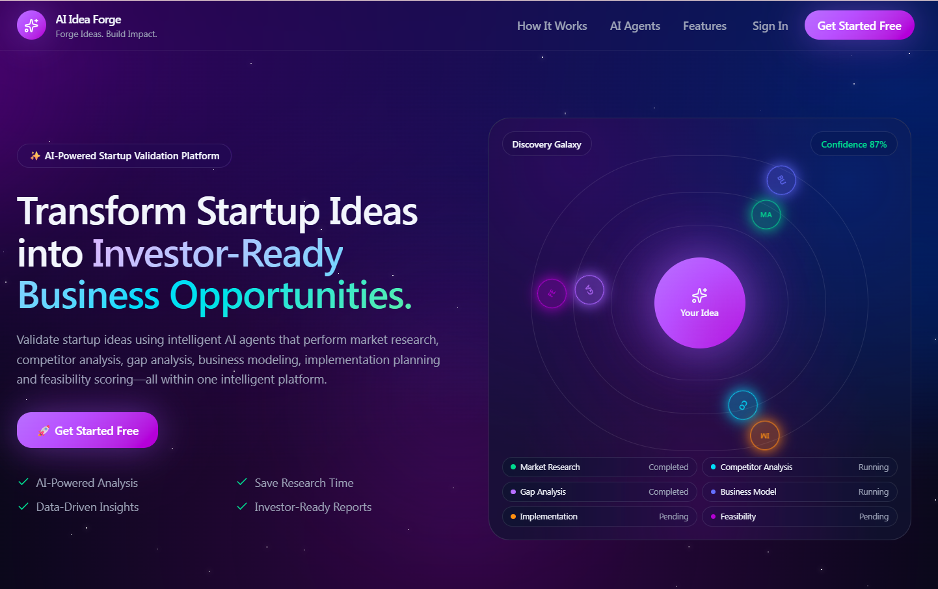
Figure 1. AI Product Discovery Platform – Landing Page
The landing page serves a dual purpose: it must communicate the product's value proposition within seconds and build enough credibility to convert a visitor into a signed-up user. Every design decision on this page was made in service of those two goals.

Hero Section Design
The hero section pairs a bold, benefit-driven headline with a concise supporting description and a single primary action. The headline is split visually — using color to highlight the outcome phrase “Investor-Ready Business Opportunities” — so that even a user skimming the page absorbs the core promise of the product without reading every word.

Call-to-Action Placement
The primary call-to-action, “Get Started Free,” appears twice: once in the top navigation bar for users who are ready to act immediately, and once directly beneath the hero description for users who arrive at the page already scrolled into the value proposition. Both use identical high-contrast button styling so the action is instantly recognizable regardless of where the eye lands.

Visual Hierarchy
The page follows a clear left-to-right, top-to-bottom reading pattern: headline and value proposition on the left, a live visual representation of the product's core mechanic on the right. This split-screen layout lets the page communicate both “what it does” (through text) and “what it looks like” (through the illustration) in the same view, without requiring the user to scroll.

Typography Choices
A large, bold display size is used for the headline to establish immediate visual weight, while body copy is set smaller and in a muted tone to keep it clearly secondary. This size and weight contrast lets the user distinguish, at a glance, between the core message and its supporting detail.

Color Palette
The page uses a dark navy-to-purple gradient background with vivid purple as the primary accent and teal/green reserved for positive or completed states. Restricting the palette to a small set of purposeful colors keeps the page visually calm despite its rich, futuristic tone, and ensures accent colors carry meaning rather than being purely decorative.

The Discovery Galaxy Illustration
Rather than a generic product screenshot, the hero visual is a stylized, simplified preview of the Discovery Galaxy interface — orbiting nodes around a central “Your Idea” core. This choice lets first-time visitors form a mental model of the product's core interaction pattern before they ever sign up, turning the hero visual into a teaching tool rather than pure decoration.

Trust-Building Layout
Underneath the primary action, a short row of checkmarked capability statements (AI-Powered Analysis, Data-Driven Insights, Save Research Time, Investor-Ready Reports) reinforces credibility immediately after the point of decision, addressing likely hesitations without requiring the user to scroll further or seek out a separate features section.

Minimal Navigation
The top navigation is deliberately shallow — a small number of links (How It Works, AI Agents, Features, Sign In) alongside the primary call-to-action. This restraint keeps the page focused on a single conversion goal rather than distributing attention across many competing paths.

Conversion-Focused Design
Collectively, the hero copy, dual CTA placement, illustrative preview, and trust-building checklist form a single continuous persuasion sequence. Nothing on the first screen is purely ornamental — every element either explains the value proposition or moves the user closer to starting an analysis.

4. Discovery Galaxy Design Concept
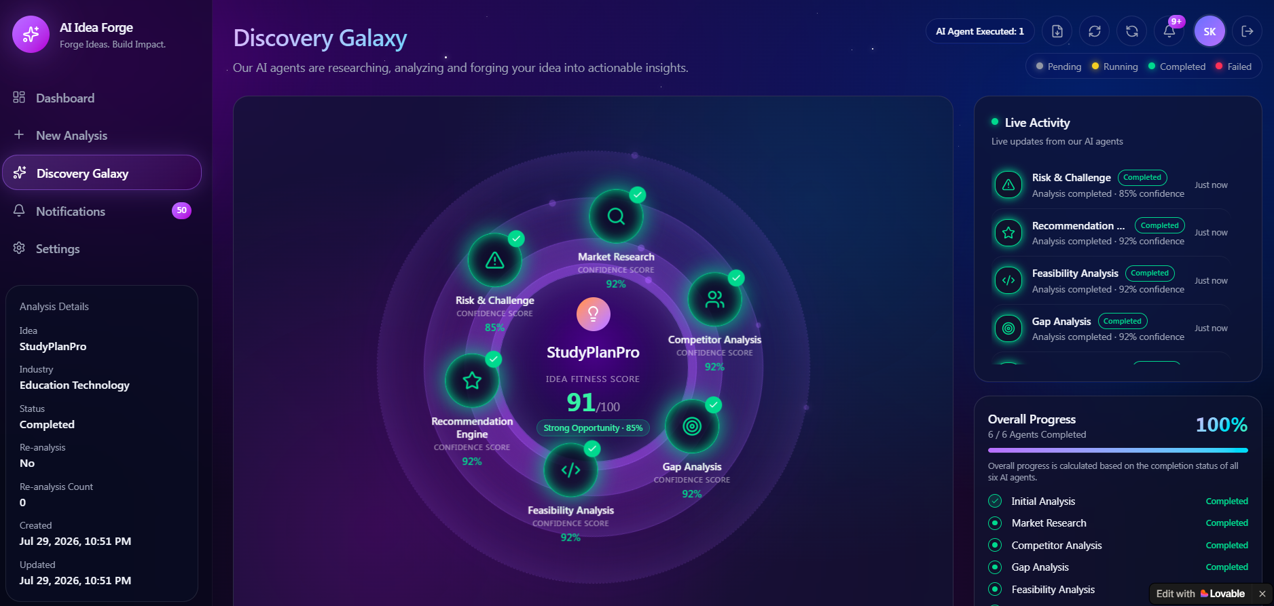
Figure 2. Discovery Galaxy – AI Agent Analysis Interface
The Discovery Galaxy is the centerpiece of the product experience and the screen where the platform's AI-first philosophy is most fully expressed. Rather than presenting analysis results as a conventional list or table, the interface visualizes the entire multi-agent process as a radial, orbit-based system.

Radial Visualization
Six AI agents are arranged in a circular orbit around a central idea marker, immediately communicating that each agent operates independently but contributes to one unified outcome. The radial layout was chosen over a linear list because it visually reinforces the idea of parallel, simultaneous analysis rather than a sequential checklist, which more accurately represents how the underlying process actually behaves.

AI Agent Orbit Concept
Each agent — Market Research, Competitor Analysis, Gap Analysis, Feasibility Analysis, Recommendation Engine, and Risk & Challenge — occupies its own node with a distinct icon, label, and confidence score. Presenting agents as discrete, labeled entities rather than anonymous processing steps helps the user understand what kind of thinking is happening at each stage, similar to consulting a panel of specialists rather than a single black-box engine.

Central Focus on the User's Idea
The center of the composition is reserved for the idea itself — its name and an overall “Idea Fitness Score.” Placing the user's own input at the visual and conceptual center of the screen, with all AI activity oriented around it, keeps the interface user-centered rather than system-centered: the AI agents exist to serve the idea, not the other way around.

Progressive Completion Visualization
Each node transitions visually as its agent completes analysis — gaining a glowing ring and a checkmark badge. This mirrors the progressive disclosure principle described earlier: the user can see, at a glance, exactly how much of the analysis is finished without needing to read status text for each item individually.

Confidence Score Placement
Confidence scores are placed directly beneath each agent's label, in immediate proximity to the result they qualify. This placement was a deliberate choice to prevent the score from being read in isolation — it is always presented as a property of a specific agent's output, reinforcing that AI-generated confidence is contextual rather than a single absolute measure of quality.

Live Activity Panel
A dedicated panel on the right surfaces a running feed of agent completions in the order they occur, each with its own confidence score and timestamp. This panel serves users who prefer a chronological, text-based account of progress alongside those who prefer the spatial, radial view — giving the same underlying data two complementary presentations.

Overall Progress Visualization
Beneath the live activity feed, a single progress bar and percentage summarize the entire analysis at a glance, backed by a itemized checklist of each stage's status. This gives the interface a clear “done/not done” signal for users who simply want to know how close the process is to completion, without needing to interpret the radial visualization.

Left Navigation Design
A persistent, icon-led navigation rail (Dashboard, New Analysis, Discovery Galaxy, Notifications, Settings) keeps core product areas one click away at all times, following standard SaaS conventions so users always retain a sense of place within the broader application.

Information Grouping
The screen is organized into three clear zones — a left-hand summary panel with static idea metadata, a central interactive visualization, and a right-hand panel of live, changing information. This grouping separates “what is this idea” from “what is happening right now” from “how far along are we,” which keeps each type of information easy to locate.

Balance Between Aesthetics and Usability
While the glowing, orbit-based visualization is highly stylized, every visual embellishment maps to a functional signal — glow indicates completion, color indicates status, and position indicates category. The design avoids decoration that does not also communicate information, keeping the aesthetic expressive without sacrificing clarity.

Why This Visualization Improves User Engagement
Because the process being represented — multiple AI agents analyzing an idea in parallel — is inherently abstract and otherwise invisible to the user, the radial visualization gives it a concrete, watchable form. Users are far more likely to stay engaged with a visible, animated process than with a static loading indicator, and the format naturally invites exploration: users are drawn to click into individual agent nodes to see what each one “found,” turning what could be a passive wait into an active discovery experience.

5. Dashboard Design Concept
While the Discovery Galaxy is the signature analysis experience, the surrounding dashboard structure applies the same design principles to give users an efficient, scan-friendly overview of their broader activity within the platform.

Dashboard-First Workflow
The product is structured so that the dashboard, rather than a settings or profile page, is the natural landing point after sign-in. This reflects the priority of getting users back into active or recent analyses as quickly as possible, rather than requiring extra navigation to reach the core value of the product.

KPI Card Layout
Key figures — such as an idea's fitness score, confidence percentage, and completion status — are presented in compact, card-based units, consistent with the summary panel style seen in the Discovery Galaxy. This card pattern is reused deliberately across the dashboard so that users apply the same reading habits everywhere in the product.

Metrics Grouping
Related metrics are grouped by theme — idea metadata together, scoring metrics together, activity and status together — rather than presented as an undifferentiated grid of numbers. This grouping mirrors how a user would naturally ask questions about their idea (“What is it?”, “How well is it scoring?”, “What has happened so far?”).

Data Visualization
Wherever possible, raw numbers are paired with a visual representation — a progress bar, a ring, or a color-coded badge — so that scores can be interpreted at a glance rather than requiring numeric comparison. This is consistent with the platform's overall preference for visual, low-effort comprehension over dense tabular data.

Decision Support
The dashboard is designed to help a user quickly answer “what should I look at next,” by surfacing status labels (Completed, Running, Pending) and confidence indicators prominently, allowing users to prioritize their attention toward the analyses or agents that most need review.

Personalized Insights
Recommendation and strategy content is presented in the user's context — tied specifically to their submitted idea — rather than as generic guidance, reinforcing that the output is a direct product of the user's own input and the platform's analysis of it.

Minimal Interaction Design
Common actions such as downloading a report, re-running an agent, or closing a detail panel are represented with small, clearly labeled icon-and-text controls placed consistently in the top-right of any expanded view, minimizing the effort required to perform routine actions.

Scan-Friendly Information Architecture
Headings, bold section labels, and consistent left-aligned icons allow users to scan a dashboard or detail panel top to bottom and immediately identify each section's purpose without reading full paragraphs, which is essential given that users are often reviewing this information under time pressure.

6. Visual Design System

Color Strategy
- Primary background: A deep navy-to-charcoal background establishes the platform's dark, technical tone and provides a neutral canvas for accent colors to stand out.
- Primary accent (purple): Vivid purple is used for primary actions, active states, and brand identity elements, tying the marketing and in-app experiences together visually.
- Status colors: Teal/green is reserved specifically for positive states — completion, success, and healthy scores — while amber and red are reserved for pending/running and warning states respectively, so status color always carries the same meaning wherever it appears.
- Contrast: Text and interactive elements maintain sufficient brightness against the dark background to remain legible, with lower-emphasis text rendered in a muted grey rather than pure white to preserve hierarchy.

Typography
- Heading hierarchy: Page titles and hero headlines use the largest, boldest type in the system; section headings step down in size and weight; body copy remains modest in size and set in a lighter weight, creating a clear three-tier reading order across every screen.
- Readability: A clean, geometric sans-serif typeface is used throughout for its legibility at both large display sizes and small metadata sizes.
- Font sizing: Numeric scores (such as the Idea Fitness Score) are given deliberately oversized treatment relative to surrounding text, since these figures are the single most important takeaway on their respective screens.

Icons
- Consistency: A single icon family is used across navigation, agent categories, and status indicators, so visual language never shifts style between sections.
- Meaning: Icons are chosen for immediate real-world association — a magnifying glass for research, a warning triangle for risk, a target for gap analysis — so meaning can be inferred without reading the accompanying label.
- Recognition: Because the same icon-to-concept mapping is reused from the landing page through to detailed agent panels, users build familiarity quickly and recognize functions rather than needing to relearn them.

Spacing
- Card spacing: Consistent internal padding and gaps are applied to all card components, giving every card — whether a KPI, an agent node, or a detail panel — a uniform sense of density.
- Padding: Generous padding around headline content prevents the interface from feeling cramped, particularly important given the visual richness of the dark, glowing aesthetic.
- Grid system: Content is arranged on a consistent column grid, allowing panels and cards to align predictably as layouts scale across different screen sizes.
- Alignment: Left-alignment is used consistently for body text and lists, while numeric and score-based content is frequently centered within its card to draw immediate attention.

Components
- Cards: Rounded-corner cards with subtle borders and soft elevation are the primary content container used throughout the product, from KPI summaries to agent detail panels.
- Buttons: A single high-contrast filled button style is reserved for primary actions, with lighter, outlined or icon-only buttons used for secondary and tertiary actions, keeping the visual weight of an action proportional to its importance.
- Navigation: The left-hand icon-and-label navigation rail remains fixed and visually consistent across every logged-in screen, anchoring the user's sense of location within the product.
- Status indicators: Small pill-shaped badges communicate state (Completed, Running, Pending, Failed) using consistent color and iconography, always paired with a text label rather than color alone.
- Progress visualization: Circular progress rings, linear progress bars, and percentage labels are used interchangeably depending on context, but always follow the same color logic established elsewhere in the system.

7. User Experience Principles
- User-centered design: Every design decision, from the radial agent visualization to the dashboard's card grouping, is grounded in what the target user — a time-constrained founder or innovator — needs to understand at each stage of their journey.
- Consistency: Color meaning, spacing, iconography, and card structure remain identical across the marketing site and the in-app experience, minimizing relearning as users move between contexts.
- Immediate feedback: Every user action, from starting an analysis to opening an agent panel, produces an immediate visible response, reassuring users that the system has registered their input.
- Recognition over recall: Icons, color-coded status, and consistent layout patterns let users recognize what a screen or component does on sight, rather than requiring them to recall instructions from earlier in their session.
- Reduced cognitive effort: Complex analysis is distilled into large, simple headline metrics (scores, percentages, status labels) so that users are never required to mentally process raw or unstructured data.
- Progressive information disclosure: Detail is layered — summary first, full analysis on demand — so that users are never confronted with more information than the current task requires.
- Clear navigation: A persistent, shallow navigation structure ensures that any core area of the product is reachable in a single click from anywhere in the application.
- Visual prioritization: Size, color, and position are used deliberately to ensure the single most important piece of information on any given screen is also the most visually prominent.
- Real-time system status: Agent status, progress bars, and live activity feeds continuously communicate what the system is doing, so users are never left uncertain about whether the platform is working or idle.

8. Overall Design Outcome
Taken together, the visual language, information architecture, and interaction patterns applied across AI Idea Forge produce an interface that feels considerably simpler to use than the underlying analysis process actually is. By consistently applying progressive disclosure, purposeful color and iconography, and a clear visual hierarchy, the platform reduces a traditionally research-heavy task to a guided, visual experience that requires minimal training to navigate.
The design directly supports AI-assisted decision-making by making the AI's process visible and its outputs traceable — every score and recommendation is presented in context, with a clear confidence indicator and a clear origin (which agent produced it), which builds the user's trust in automated analysis rather than asking them to accept it blindly.
The dark, futuristic visual language reinforces the product's identity as a modern, intelligent tool, which is particularly well suited to its target audience of startup founders and product innovators — users who expect the tools they rely on to look and feel as forward-thinking as the ideas they are being used to validate. Overall, the interface succeeds in balancing an ambitious, expressive visual style with the clarity and usability expected of a professional, decision-support product.

